Microsoft SQL Server. Lab #1. Introduction to SQL. Distributions. Installing Microsoft SQL Server.
Target: teach how to correctly configure Microsoft SQL Server 2008 on both the server and client sides.
Theoretical material: Before performing the lab, it is recommended that you study Lecture 1, “Introduction to Database Theory,” which covers the basic concepts of databases, and Lecture 2, “Microsoft SQL Server 2008 Components,” which covers in detail all the main components of MS SQL Server 2008 that will be configured during this lab.
Reporting requirements: during the lab work, you will need to write a report. The information needed for the report will be indicated in the work by the words "Write down in the report...".

Task 1. Explore the SQL Server Configuration utility.
Instructions for implementation:
- On the server, run the SQL Server Configuration Manager utility and use it to determine the list of services running on the server. Record this list in a report.
- Note: Additional options for managing the operation of services are provided by the Windows XP Services administration utility, which is accessed via the Control Panel – Administrative Tools folder.
- On a server with installed MS SQL Server 2008, use the Services utility to determine the parameters for starting MS SQL Server services and record them in the report. (If you do not have access to the Services utility, then use SQL Server Configuration Manager).
- Determine which network libraries can be used to establish a connection to MS SQL Server (see Fig. 1.1). Which libraries are currently active? Record this information in the report.
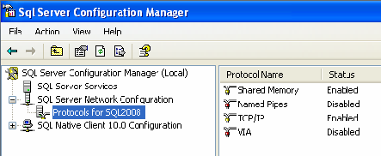
Fig. 1.1. Server-side protocols through which you can connect to it

- Using SQL Server Configuration Manager, determine which network libraries the client can use to connect to MS SQL Server (see Fig. 1.2). Write the list of libraries to the report.
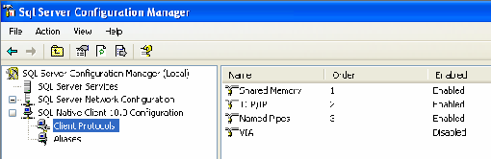
Fig. 1.2. Client-side protocols through which it can connect to the server

Task 2. Creating a server alias for client connections.
Before you start working with the server, you need to configure the connection parameters. To do this, in the SQL Server Configuration Manager utility, in the SQL Native Client Configuration – Client Protocols node, add the network library configuration, then specify the logical name of the server, select the required library from the list and define its parameters. For example, when interacting based on the TCP/IP stack, you need to specify the name of the network node on which MS SQL Server is installed and the TCP port number used for the connection (see Fig. 1.3).

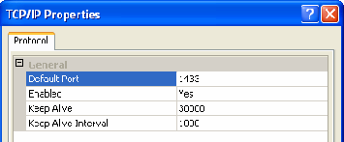
Fig. 1.3. TCP/IP protocol properties
Instructions for implementation:
- Determine and record in the report the network name of the computer on which MS SQL Server is installed.
- In the context menu (right mouse button) for the SQL Native Client Configuration – Aliases node, execute the New alias… command, set the Alias ​​Name to MyServ, select the TCP/IP protocol, and specify the previously defined name in the Server field.
- What port number should be specified when setting up this connection and why? Record in the report.

Task 3. Establish a connection to the SQL server.
Instructions for implementation:
- On the workstation – the client computer – start SQL Server Management Studio and select from the list the logical server name MyServ, defined in the previous task using the SQL Server Configuration Manager utility. If the required server is not in the list, you can select <Browse for more…> and find the required server in the list of servers to which a connection can be made.
- Connect to the MyServ server using MS SQL Server authentication: account "sa", no password.
- To write a new query, you need to execute the New Query command located on the SQL Server Management Studio toolbar. This will open a new tab that provides the following options:
  - a header that specifies the logical name of the server, the current database, and the name of the user who established the connection;
  - query area used to enter queries passed to MS SQL Server;
  - the results area, which displays the results of the query, and the display method is set by the Messages buttons (in the formtext) and Results (in the form of a table), respectively.
- Using the SELECT @@version command, determine and write to the report information about the version of MS SQL Server and operating system used (the query result should be displayed in text form) (Fig. 1.4).
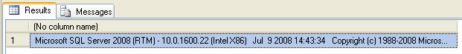
Fig. 1.4. Information about the MS SQL Server version
Note: To execute a query, you need to run the Query – Execute (F5) command, and to analyze the correctness of its syntax, you can use the Query – Parse (Ctrl+F5) command.
SQL Server Management Studioallows you to open multiple query windows and work with multiple databases simultaneously. Each window establishes its own connection to MS SQL Server based on different user accounts and their passwords. To create a new connection, use the File – New – Database Engine Query command.
The contents of the current connection request area can be saved to a file on an external drive using the File – Save command.
- Use the Object Explorer panel to determine the names of the supported databases and which server databases are system databases (to do this, expand the Databases node in the Object Explorer panel). Record this information in the report.

Task 4. Study the configuration parameters of MS SQL Server.
Configuration of the MSSQLServer service can be performed either by a special stored procedure executed in the SQL Server Management Studio utility, or graphically by means of the same utility. The choice of method does not matter, since the graphic method provides access to system data using the same stored procedure, only in a more visual form.
Instructions for implementation:
- To change the service settings using SQL Server Management Studio, select the desired server in Object Explorer and select Properties from the context menu. In the dialog box that appears, you can configure all the necessary settings.
- Display the list of MyServ server parameters (see Fig. 1.5).
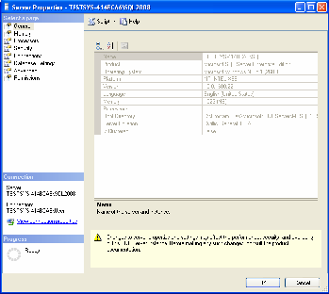
Fig. 1.5. MS SQL Server 2008 Properties
The General tab displays basic information about the system: operating system version, memory size, number of processors, etc., as well as server service startup parameters.
The Memory tab allows you to manage memory allocation for MS SQL Server actions: either dynamic memory management or set a fixed size.
The Security tab is used to define the user authentication type and also to define server access audit parameters. You can configure the server to use a specific account under which the MSSQLServer service will be launched.
The Connections tab allows you to configure client connections to the server. The maximum number of users that can simultaneously connect to the server. If zero is specified, their number is 32767.
The Advanced tab contains some general server settings. For example, you can define the default language for server messages or adjust year 2000 support, which determines how the last two digits of the year are interpreted.
The Database Settings tab is used to specify the settings for newly created databases: index parameters and parameters for working with backup devices, and the database recovery time.
- Determine and record in the report the server's root directory, the number of processors in the system, the user authentication type, and the maximum number of users supported by the server.
- Explore other MS SQL Server properties available in this dialog.
Microsoft SQL Server. Lab #2. Introduction to Transact-SQL
Objective: learn the basic operators and algorithmic constructs of Transact-SQL.
Theoretical material: Before performing the lab, it is recommended that you study Lecture 3, “General Information about Transact-SQL,” since it provides a general description and purpose of the SQL language, and also covers all the algorithmic constructs available in SQL.
Reporting requirements: based on the results of the work, you need to present a set of SQL scripts that solve the problems from the “Independent Work” section.

Task 1. Connect to the MyServ server using the Management Studio utility.
Instructions for implementation:
- Launch SQL Server Management Studio from the Start menu – Programs – Microsoft SQL Server 2008.
- Select authentication type: SQL Server Authentication. Specify User name: sa, and Password: empty and click Connect.

Task 2. Determine whether the user has the right to select from the Product table.
Directions for implementation:
- Set as current databaseAdventureWorks2008. This can be done in one of the following ways:
  - run the command USE AdventureWorks2008;
  - Select AdventureWorks2008 from the drop-down list (see Fig. 2.1).
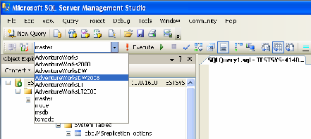
Fig. 2.1. Selecting the current database
- Using the functionobject_idlet's get the identifier of the Product table.
- FunctionPermissionsreturns a 32-bit mask, where each bit represents the current user's right to a certain action. The value of the bit depends on the parameters with which the function was called. The Permissions function can be called in one of three ways:
  - without parameters – returns a list of permitted user actions that the user can perform in the current database;
  - with one parameter obect_id – returns a list of valid actions on an object, for example, on a table;
  - with two parameters: object_id and attribute – returns the allowed actions on the attribute.
The table lists the permitted actions according to the different ways of calling the Permissions function. Each action is indicated by the number and decimal value of the corresponding bit.
Table 2.1. Permitted actions of the function call Permissions
Bit number | Bit  (in decimal form) | Permitted action
Bit number | Bit  (in decimal form) | No parameters | Object_id | Object_id  and attribute
0 | 1 | CREATE DATABASE | SELECT ALL | SELECT
1 | 2 | CREATE TABLE | UPDATE ALL | UPDATE
2 | 4 | CREATE PROCEDURE | REFERENCES  ALL | REFERENCES
3 | 8 | CREATE VIEW | INSERT
4 | 16 | CREATE RULE | DELECT
5 | 32 | CREATE DEFAULT | EXECUTE
6 | 64 | BACKUP DATABASE
7 | 128 | BACKUP LOG
8 | 256 | Reserved
12 | 4096 |  | SELECT ANY
13 | 8192 |  | UPDATE ANY
14 | 16384 |  | REFERENCES  ANY

In this case, we are interested in the least significant (zero) bit – the right to SELECT ALL.
- Example of a function callPermissions(Fig. 2.2): SELECT Permissions (object_id('production.product'))

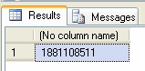
Fig. 2.2. Result of the Permissions function

- To determine whether the bit we are interested in is set, we can use the bitwise AND (&) operation, then the final result will look like this:
IF Permissions (object_id('production.product'))&1=1SELECT 'Have select permission'
ELSE
SELECT 'No selection rights'
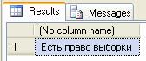
Fig. 2.3. Result of the Permissions function for outputting a text description
- Instead of the SELECT operator, you can use the PRINT operator, which simply allows you to output data as text, rather than as a table, as SELECT does. Then the code will look like this:
IF Permissions (object_id('production.product'))&1=1PRINT 'Have the right to select'
ELSE
PRINT 'No selection rights'
And the result will be displayed not on the Results tab, but on the Messages tab (Fig. 2.4).
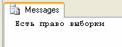
Fig. 2.4. Result of using PRINT

Task 3. Display the name of the computer on which the command is executed. If the computer name is more than nine letters, then display only the first six letters.
Directions for implementation:
- To get the computer name, use the functionHOST_NAME().
- To determine the length of a string, you can use the functionDataLength.
- Example of completing the task:
IF (DATALENGTH(HOST_NAME()) / 2 > 9) SELECT LEFT(HOST_Name(), 6) + '...'
ELSE
SELECT HOST_Name()
Comment. Note that we divided the result of the DATALENGTH function into two. This is because HOST_NAME() returns the nvarchar type, in which two bytes are allocated for each character.

Task 4. Count the number of digits in a number.
Directions for implementation:
- One from the possible solutions to this problem (see Fig. 2.5): DECLARE @num int, @cnt int
SET @num = 19
IF (@num = 0) SET @cnt = 1 ELSE BEGIN
SET @cnt = 0

WHILE (@num <> 0) BEGIN
SET @cnt = @cnt + 1 SET @num = @num / 10
END END
SELECT @cnt AS 'Number of digits'
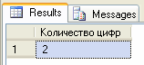
Fig. 2.5. Result of the code execution

Independent work.
- Optimize the code for solving task 4: get rid of the conditional operator, only the loop should remainWHILE, and the code should still work for both zero and positive numbers, as well as negative ones.
- Determine if a user has permission to access a field'CardNumber', tablesCreditCardin the databaseAdventureWorks2008. If access is available, then display “Access available”, otherwise – “Access denied”.
- Write a program to convert weight from pounds to kilograms (1 pound equals 453.6 g). The result should be displayed as follows, for example:
3.3 lb(s) is 1 kg 496 g.
- Display information about the current server, account, and database user names as follows:
- You are logged on to server User400-01\SQL2008 as User400-01\User with dbo permissions.
- Determine the number of hours and minutes that have passed since the MS SQL Server services were started.
- Determine if the current year is a leap year.
- Find the sum of numbers in a given string of characters.
- Determine the amount of payment for sending a telegram. A period is used to indicate the end of a telegram. The cost of one word is 33 kopecks, output the result indicating the number of rubles and kopecks. The line may contain any number of spaces.
- Using the Caesar cipher, encrypt a given string of text. The idea behind this encryption method is that the alphabet is arranged clockwise. To encrypt, the letters of the text are replaced by letters that are a given number of letters (shift) clockwise.
- The user's last name, first name and patronymic are known. Find his/her personality number. The rule for obtaining the personality number: each letter is assigned a number - the ordinal number of the letter in the alphabet. These numbers are added up, if the resulting sum is not a single-digit number, then the digits of the number are added up again and so on until a single-digit number is obtained.

Microsoft SQL Server. Lab #3. Data Sampling
Target:teach how to use the SELECT statement and its main sections to select data according to specified conditions.
Theoretical material: Before performing the lab work, it is recommended to study Lecture No. 4 “Data Selection”, which studies one of the main SQL language operators – SELECT and explains the purpose of each of its sections.
Reporting requirements: based on the results of the work, present a set of SQL scripts that solve the problems from the “Independent Work” section.
Task 1. Connect to the MyServ server using the Management Studio utility.
Instructions for implementation:
- Launch SQL Server Management Studio from the Start menu – Programs – Microsoft SQL Server 2008.
- Select authentication type: SQL Server Authentication. Specify User name: sa, and Password: empty and click Connect.

Task 2. Get a list of countries with their code and the last date of record modification from the CountryRegion table of the AdventureWorks2008 database.
Directions for implementation:
- To complete the task we will need attributesCountryRegionCode, [Name],ModifiedDatefrom the tablePerson.CountryRegion. Note that the table name is preceded by the Person schema name, which is used to manage objects related to employees and departments.
- To rename columns, we will use the keywordAS.
- Make sure, what BDAdventureWorks2008is current, and execute the following query: SELECT CountryRegionCode AS 'Code', [Name] AS 'Country',
ModifiedDate AS 'Modified Date'FROM Person.CountryRegion
The result of executing the query is shown in Fig. 3.1.
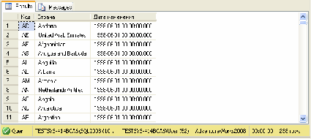
Fig. 3.1. List of countries

Task 3. Get a list of employees with their last name and first character of their first name, as well as their identification number. The list should be sorted by the employee's last name and first name.
Directions for implementation:
- We will have to rename the first column using the operatorAS, since it requires combining data from two columns:LastNameAndFirstName.
- To get only the first letter of the name, we will use the Substring function.
- To sort the resulting table, you need to use the sectionORDER BY.
- Run the following code:
SELECT LastName+' '+Substring(FirstName,1,1)+'.' as [Employee Name], BusinessEntityID FROM Person.Person
ORDER BY [Employee name]
The result of executing the query is shown in Fig. 3.2.
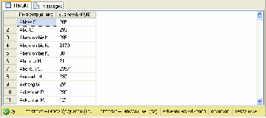
Fig. 3.2. List of employees
Comment.By default, sorting is performed in ascending order, which corresponds to the reserved word ASC (may not be specified); for sorting in descending order, DESC is specified.

Task 4. Get a list of products whose price is in the range from $12 to
$20, sorted by price.
Directions for implementation:
- To select records according to a given criterion, you must use the section
WHERE.
- You can use a compound condition, then the code will look like this: SELECT [Name], ListPrice From Production.Product
WHERE (ListPrice>=12) and (ListPrice<=20)

ORDER BY 2
- Another option: replace the two comparison operators with one logical operatorBETWEEN, with the help of which you can get an answer to the question of whether the value lies in the specified range:
SELECT [Name], ListPrice From Production.Product WHERE ListPrice Between 12 and 20
ORDER BY ListPrice
The result of executing the query is shown in Fig. 3.3.
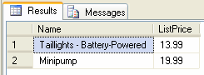
Fig. 3.3. List of products with price from $12 to $20

USA.
Task 5. Display the names of employees and their positions living outside
Directions for implementation:

- To search for a pattern of character strings, a logical operator is used.LIKE, which is most often used in situations where an exact match is not known.
- In the template we will need to specify a service character%, which means any string consisting of 0 or more characters.
- Using tableHuman Resources.vEmployeeLet's create a query: Select LastName, JobTitle From HumanResources.vEmployee Where CountryRegionName Not Like '%United States%' The result of executing the query is shown in Fig. 3.4.
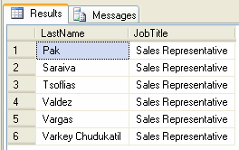
Fig. 3.4. Employees residing outside the United States

Task 6. Get a list of employees from the USA and Canada.
Directions for implementation:
- To determine whether an expression matches one of the values ​​listed in a given list, a logical operator is used.IN. This operator can always be written as a group of conditions united by an operandOR.
- Request using the operatorINwill look like this: Select LastName, JobTitle From HumanResources.vEmployee
WHERE CountryRegionName IN ('United States', 'Canada') The result of the query is shown in Fig. 3.5.
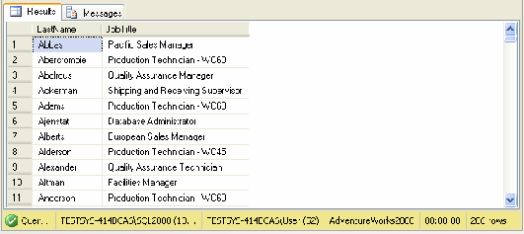
Fig. 3.5. Employees from the USA and Canada

Task 7. Get a list of products that do not have a color specified.
Directions for implementation:
- To check for the absence of a value, the IS NULL sampling function is used.
- Let's make it up next query on tableProduct: SELECT [Name] FROM Production.Product WHERE Color IS NULL
The result of executing the query is shown in Fig. 3.6.
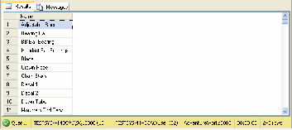
Fig. 3.6. Products for which color is not specified

Independent work
- Display information about the delivery methods of the product (ShipMethod), if the active user has the right to receive this data.
- Construct a query that returns a list of employees (tableEmployee) indicating themEmployeeID, date of birth (in dd.mm.yyyy format) and age as of today.
- Hint: To convert a value of one type to a value of another type, use the function:CONVERT(type, expression[, style]).
- Identify the list of products that have been discontinued (usingSellEndDate), indicating their color.
- Get warehouse locations fromProduction.Location,containing 'Paint' in their name.
- Display a list of countries where customers are registered. The selection should be made from the viewvIndividualCustomer, and not from the table, because the table does not contain enough information for such a request.

Microsoft SQL Server. Lab #4. Stored Procedures
Target:teach how to create and call custom stored procedures, as well as pass parameters to them.
Theoretical material: Before performing the lab, it is recommended that you study Lecture 3, “General Information about Transact-SQL,” which provides the basics of SQL language syntax, and Lecture 5, “Auxiliary Database Objects,” which provides basic information about stored procedures.
Reporting requirements: based on the results of the work, present a set of SQL scripts that solve the problems from the “Independent Work” section.

Task 1. Create a stored procedure that outputs the name of the computer on which the command is executed. If the computer name is more than nine letters, then output only the first six letters.
Instructions for implementation:
- To get the computer name, use the functionHOST_NAME().
- For To create a procedure, run the following code: CREATE PROCEDURE Test AS
IF (DATALENGTH(HOST_NAME()) / 2 > 9) SELECT LEFT(HOST_Name(), 6) + '...' ELSE
SELECT HOST_Name()
Comment. The stored procedure will be created in the current database.
- Make sure that the stored procedure has been created (see Figure 4.1).

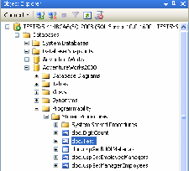
Fig. 4.1. List of stored procedures in the database
- Call the created stored procedure by executing the following code: TEST

Task 2. Create a stored procedure that takes a number as a divisor and returns the number of digits in it through the OUTPUT parameter.
Instructions for implementation:
- Create a stored procedure DigitCount with two parameters:
CREATE PROCEDURE DigitCount @num int,
@cnt int OUTPUT AS
IF (@num = 0) SET @cnt = 1 ELSE BEGIN
SET @cnt = 0
WHILE (@num <> 0) BEGIN
SET @cnt = @cnt + 1 SET @num = @num / 10
END END
- Call procedureDigitCountand make sure it works correctly: DECLARE @num int = 1249
DECLARE @cnt int
EXEC DigitCount @num, @cnt OUTPUT SELECT @cnt
Comment.Please note that in this case the EXEC keyword is required before calling the stored procedure, because the stored procedure is specified in a block of other SQL commands, and is not executed alone.

Independent work
- Determine the number of system stored procedures.
Indication. Design the solution to the following problems in the form of stored procedures.
- Determine the season for a given date: fall, winter, spring or summer.
Comment.To control the date format, use the following command: SET DATEFORMAT Format.
The Format option specifies the date input format and can take the following values ​​–
mdy, dmy, ymd, myd and dym (where m, d and y are day, month and year respectively).
- The user's date of birth is known. Check whether he or she is 16 years old or younger.
- Determine whether a character string is an email address. Make the source code of the procedure unreadable. Prove that the steps are correct. Hint: the string must contain the character@, after which there must be at least one dot.
- Delete all procedures you have created.

Microsoft SQL Server. Lab #5. Microsoft SQL Security System
Server
Target:teach how to use system stored procedures to manage MS SQL Server logins and database users, as well as to allow and prohibit certain actions to be performed by a certain user.

Theoretical material: Before performing the lab work, it is recommended to study Lecture No. 6 “Database Security System”, which covers in detail the issues of managing user accounts and rights.
Reporting requirements: based on the results of the work, submit a report with screenshots containing SQL commands and the results of their execution for each task from the section
"Independent work".
Task 1. Connect to the MyServ server using the Management Studio utility.
Instructions for implementation:
- Launch SQL Server Management Studio from the Start menu – Programs – Microsoft SQL Server 2008.
- Select authentication type: SQL Server Authentication. Specify User name: sa, and Password: empty and click Connect.

Task 2. Define the list of server roles.
Instructions for implementation:
- Create a new query either via the File – New – Query with Current Connection menu command or using the New Query button on the toolbar.
- In the SQLQuery1.sql tab, execute the sp_helpsrvrole command (see Fig. 5.1).
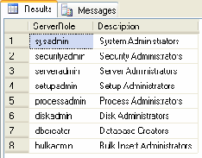
Fig. 5.1. MS SQL Server server roles
Comment.For a more visual presentation of data, use the method of displaying information in the form of a table (the Results to Grid/Results to Text buttons on the toolbar or via the Query – Results To menu commands).

Task 3: Create and configure a new TempUser account to log in to SQL Server.
Instructions for implementation:
- To add an account, use the sp_addlogin stored procedure: sp_addlogin 'TempUser', 'Password!'
Comment.You can use SQL Server Management Studio to get help on Transact-SQL commands and stored procedures by highlighting the operator name and pressing F1.
- Make sure that the account was added using the sp_helplogins stored procedure (see Figure 5.2).
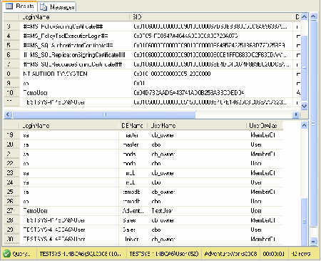
Fig. 5.2. List of MS SQL Server user names
- Try to log in to the server using the created account.

- Log in again under the sa account, since further actions will again require administrator rights.
- To assign a login account to a built-in server role, use the following procedure:
sp_addsrvrolemember 'TempUser', 'securityadmin'
Task 4. Identify the list of AdventureWorks2008 database roles and role members.
db_owner.
Instructions for implementation:
- Execute sp_helprole to list both built-in and user-defined database roles.
- Use the sp_helprolemember 'db_owner' command to determine the members of the db_owner role (see Figure 5.3).
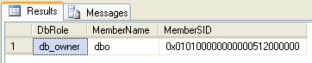
Fig. 5.3. List of members of the db_owner role

Task 5. Create a new database user for the TempUser login.
Instructions for implementation:
- Add a user using a stored procedure: sp_adduser 'TempUser', 'MyFirstUser'
- Use sp_helpuser to verify that the user was added. What role was assigned to the user?
- Add the db_datareader role to the user: sp_addrolemember 'db_datareader, 'MyFirstUser'

Task 6. Set up access rights for the user Andy: explicitly grant the right only to select from the Product table and update only the Name and ListPrice fields of this table.
Instructions for implementation:
- The following command grants the TestUser user in the AdventureWorks2008 database the right to select and modify data in the Orders table in that database: GRANT select, update on AdventureWorks2008.Production.WorkOrder to TestUser
- The following command grants user Andy permission to only select data from the Name and ListPrice fields of the Product table in the AdventureWorks2008 database:
GRANT select on AdventureWorks2008.Production.Product (Name, ListPrice) to Andy

Task 7. Learn how to perform the above functions using the graphical interface of the Management Studio utility.
Instructions for implementation:
- You can view the list of existing accounts and their parameters by selecting the Logins group in the Security folder of the server.
- To create a new login account, you need to execute the New Login… command from the context menu of the Logins node, and in the dialog box that appears, specify:
  - General tab: user name, authentication type (if authenticated by means of MS SQL Server – set a password), database to which the user connects automatically, default language;
  - Server Roles tab: server roles that the created account will belong to;
  - User Mapping tab: access to one of the databases created on the server, in the User field enter the name of the database user and include the created user in one of the existing roles.
Comment.To change the parameters of an existing user account, select it from the list and execute the context menu command Properties; to delete it, select Delete.
- To display the list of server roles, select the Server Roles group in the server's Security folder. Viewing the users included in this role and the permissions assigned to it is done by executing the Properties context menu command.

- Note: Built-in server roles cannot be removed from the system, and their defined permissions cannot be changed. It is also prohibited to create your own server roles.
- The Security/Users group of a database is used to view and manage user parameters for a particular database. Accounts are displayed in the User Name field, and the corresponding login accounts are displayed in the Login Name field.
To create a new database user, you must run the New User… command, then enter the user name in the User name field, and select the appropriate login account from the Login Name list. You can also include the user in database roles.
Comment.To change account parameters, use the Properties command, and to delete them, use the Delete command.
- The Roles group is used to display a list of database roles. To view users in this group, you must run the Properties command.
- To assign permissions to a security object, you must select it in the Users group (to change permissions for a specific database user) or in the Roles group (for permissions for a specific role). The Securables tab is used for these purposes.
The tab that appears lists all database objects with possible access rights. You can set one of three access states: grant (check mark), deny (cross) and implicit rejection (empty field) – in the corresponding field.

Task 8: Unassign an account role and delete the account

TempUser.
Instructions for implementation:
- Removing a role assigned to a user can be done using the procedure: sp_droprolemember 'db_datareader', 'MyFirstUser'
- To delete a database user, use the following procedures: sp_dropuser 'MyFirstUser'
- Unassigning an account from a specific role is done using a stored procedure:
sp_dropsrvrolemember 'TempUser', 'securityadmin'
- To drop an account, execute the stored procedure: sp_droplogin 'TempUser'

Independent work
- List all server roles and the actions allowed to users of the dbcreator role.
- Determine which server role is assigned to the sa system account.
- Determine which role a user has the ability to create and delete login accounts.
- Changing the user account login password is performed using the sp_password procedure.
- Create your own login account with a connection to the AdventureWorks2008 database, prove the correctness of the actions performed. Assign the rights to create and change databases to the created account, prove the correctness of the actions performed. Connect to MS SQL Server using the created account, and create another user account for login, explain the result.
- Create a user manager for the AdventureWorks2008 database based on the login account you created earlier. Prove that you have done this correctly.
- Assign the manager user a role that only allows viewing the contents of the AdventureWorks2008 database.
Comment.To check the correctness of the actions performed, you can execute an arbitrary query to this database, for example, displaying the contents of the Production.WorkOrder table:
SELECT * FROM Production.WorkOrder.
- Forbid the user manager to view the AdventureWorks2008 database data by assigning the necessary role. How can I prove that the changes were made correctly?

- How many database users can be created based on one user login account? Justify your answer.
- Using SQL Server Management Studio, create a user account that uses SQL authentication to connect to the AdventureWorks2008 database by default and has diskadmin server role rights.
- Define the list of users included in the diskadmin role and its permissions.
- In the AdventureWorks2008 database, create a user based on the login account you created earlier.
- For the previously created AdventureWorks2008 database user, determine what role this user is a member of and what is its purpose. Does this user have the right to select data from the Production.Product table of this database? Justify your answer and verify it by retrieving data using the SELECT * from Production.Product command.
- In the AdventureWorks2008 database, create the managers role. For this role, define the right to select data from the Production.Product table of the AdventureWorks2008 database. Assign the managers role to the user created earlier. Does this user now have the right to select data? Check the conclusion. To what other objects of the AdventureWorks2008 database does this user have the right to access? Justify and check the conclusion.
Microsoft SQL Server. Lab #6. Database Management
Objective: teach how to use SQL commands to create and modify databases
structures, as well as perform backups and restore databases from backups.
Theoretical material: Before performing the laboratory work, it is recommended to study lecture No. 7 “Database structure in MS SQL Server”, which examines the organization of the database within the MS SQL Server 2008 DBMS, as well as the main structural elements of the database.
Reporting requirements: based on the results of the work, submit a report with screenshots containing SQL commands and the results of their execution for each task from the section
"Independent work".

Task 1. Create a Sales database with a log.
Directions for implementation:
- Let's take advantage CREATE DATABASE function: CREATE DATABASE Sales
ON
( NAME = Sales_dat, FILENAME = 'e:\saledat.mdf', SIZE = 10,
MAXSIZE = 50, FILEGROWTH = 5)
LOG ON
( NAME = Sales_log, FILENAME = 'e:\salelog.ldf', SIZE = 5MB,
MAXSIZE = 25MB, FILEGROWTH = 5MB)
- Run the following code to verify that the database was created with the required parameters (Figure 6.1):
sp_helpdbSales
The result of execution is shown in Fig. 6.1.

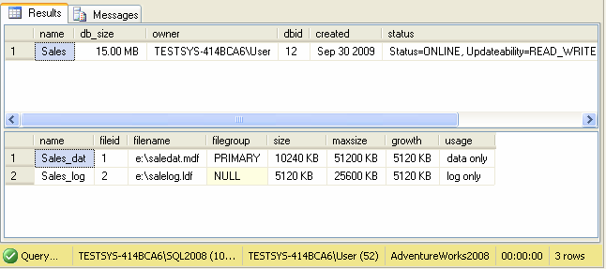
Fig. 6.1. Database information

Task 2. Create a backup copy of the Sales database.
Directions for implementation:
- Let's create a backup device: sp_addumpdevice 'disk', 'backupdisk', 'e:\sales.bak'
- Let's take advantage BACKUP function to perform backup: BACKUP DATABASE Sales TO backupdisk
The result of execution is shown in Fig. 6.2.
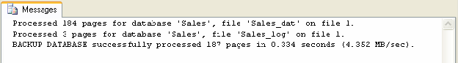
Fig. 6.2. Result of executing the BACKUP operator

Independent work
IndicationTo prove that actions were performed correctly, you can use sp_helpdb procedures before and after performing some operation.

Task 1.
- Create a user with permission to create and delete databases.
- Create your own database with a main file size of 5 MB and a log file size of 2 MB. The main file can grow to 10 MB in 20% increments. The log file size can grow to 5 MB in 1 MB increments. The location of the files on the disk is D:\MSSQL\DATA.
- Make sure the database is created properly.

Task 2.
- Review the list of database options that can be set.
- Review the list of installed parameters of the database you created.
- Specify that the database is used by the owner only and in single user support mode.
- Make sure you change the database settings.

Task 3.
- Rename the database you created.

Task 4.
- Create your own file group.
- For your database, define another 2 MB file and place it in the created workgroup.
- Prove that your actions were correct.

Task 5.
- Set up automatic data compression for your database.

Task 6.
- Determine the disk space information consumed by the AdventureWorks2008 database.
- Shrink the AdventureWorks2008 database so that it contains only 25% of the space currently available to it.

- Prove the correctness of the action performed.

Task 7.
- For the AdventureWorks2008 database, add another file to the PRIMARY filegroup.
- Compact the AdventureWorks2008 database. Justify your selections.
- Prove that the database compression actually happened.

Task 8.
- Create a backup copy of the AdventureWorks2008 database. Backup device physical name: D:\MSSQL\BACKUP\AdventureWorks_backup.bak.
- Back up the AdventureWorks2008 database transaction log.

Task 9.
- Remove the AdventureWorks2008 database.
- Restore the deleted database from the device with the physical name AdventureWorks_backup.bak.
- Prove the correctness of the action performed.

Microsoft SQL Server. Lab #7. Data selection from several
tables
Target:teach how to use the JOIN construct to outer and inner join two or more tables.
Theoretical material: Before performing the lab work, it is recommended to study Lecture No. 4 “Data Selection”, which studies one of the main operators of the SQL language – SELECT, and explains the purpose of each of its sections, and also considers issues of joining several tables.
Reporting requirements: based on the results of the work, present a set of SQL scripts that solve the problems from the “Independent Work” section.

Task 1. Get a list of products with their categories.
Instructions for implementation:
- Since the Product table of the normalized AdventureWorks2008 database stores only the product category ID, to obtain a list of products with their categories, you need to join the Product and ProductSubcategory tables.
- Before specifying the field in the SELECT statement, you will need to use the Product and ProductSubcategory table names to resolve conflicts, since both tables have Name fields.
SELECT Product.Name, ProductSubcategory.Name, Product.ListPrice FROM Production.Product INNER JOIN Production.ProductSubcategory
ON Product.ProductSubcategoryID = ProductSubcategory.ProductSubcategoryID The result of the query is shown in Fig. 7.1.
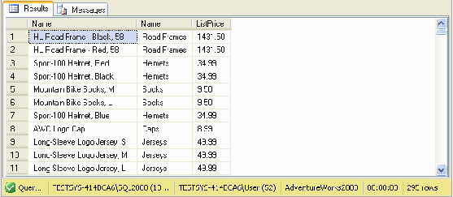
Fig. 7.1. The result of joining two tables – products with a category indication
Comment.With this join, products that do not have a category specified are not included in the result set.

Task 2. Create a query that returns the customer's name and the date the order was placed.
Instructions for implementation:

- Run the following code:
SELECT FirstName, LastName, OrderDate FROM Person.Person LEFT JOIN Sales.Customer
ON Customer.PersonID = Person.BusinessEntityID LEFT JOIN Sales.SalesOrderHeader
ON Customer.CustomerID = SalesOrderHeader.CustomerID The result of the query execution is shown in Figure 7.2.
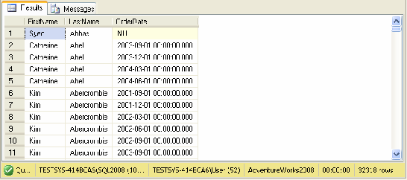
Fig. 7.2. The result of joining three tables - customers and the dates they placed orders For people who did not place orders, the OrderDate field contains a NULL value.
With a right join (keyword RIGHT JOIN), all records from the right table are included in the result, regardless of whether there is a corresponding row for them in the left table or not. Modify the above query so that it produces the same results when using a right join.

Task 3. Using a cross join, you can list all possible delivery methods for goods in the Northwind database (supplied with MS SQL Server before AdventureWorks2008).
Instructions for implementation:
SELECT DISTINCT Suppliers.Country, Orders.ShipCountry FROM Suppliers CROSS JOIN Orders

Independent work
- Display the last name and first name of customers from the vIndividualCustomer view, and the number (SalesOrderNumber) and date of their orders, starting from January 1, 2003, from the SalesOrderHeader table. If a company places multiple orders on the same day, only one record should be returned.
Indication: To limit the number of records in the resulting data set, you must specify a condition in the WHERE clause.
- Get a list of products with order number and customer, ordered on a certain day, for example, January 1, 1998. Design the solution as a stored procedure.
- Construct a query that returns the order number, the customer's first and last name, and the last name of the employee who processed the order.
- Create an order query for each product, specifying its name, price, and quantity using inner and outer joins.
- What is the difference between using inner and outer joins when solving problem #4?
- Suggest a cross join option for the AdventureWorks2008 database and implement it in SQL.
- Obtain a data set containing the following information: names and surnames of customers, their addresses; names of manufacturing companies, with their addresses; names and surnames of employees.
Indication: the last name and first name must be displayed as one field. Data selections should be made not from tables, but from the following views: vEmployee, vIndividualCustomer, vVendor.

Microsoft SQL Server. Lab #8. Analytical Data Sampling
Target:teach how to use aggregate functions and the GROUP BY section of the SELECT statement for analytical data retrieval.
Theoretical material: Before performing the lab, it is recommended that you study Lecture #4, “Data Selection,” which examines the SELECT operator and explains the purpose of each of its sections, as well as discusses issues of data grouping.
Reporting requirements: based on the results of the work, present a set of SQL scripts that solve the problems from the “Independent Work” section.

Task 1. Calculate the average price of goods.
Directions for implementation:
- To calculate the average price, you need to use the aggregate function AVG.
- The aggregate function will combine the values ​​of the ListPrice field so that the following code will return only one number (Figure 8.1):
SELECT AVG(ListPrice) FROM Production.Product
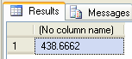
Fig. 8.1. Average price of goods

day.
Task 2. Determine the names of customers who placed orders in the last accounting period.
Directions for implementation:

- To make things simple, let's first get a list of only CustomerIDs, not customer names. You can use the following query to do this:
Select CustomerID From Sales.SalesOrderHeader
Where OrderDate=(SELECT Max(OrderDate) From Sales. SalesOrderHeader) The result of the query is shown in Fig. 8.2.
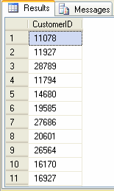
Fig. 8.2. IDs of customers who placed orders on the last accounting day
Comment.This query is executed in two stages: in the first stage, the subquery is executed as an independent query, which returns a value used in the second stage when executing the outer query.
- To fully solve the problem, we will select the names of all customers from the Person table that are present in the list obtained in the previous paragraph. However, the Person table does not contain the CustomerID field, so we will also have to join it with the Customer table. The resulting code will look like this:
SELECT FirstName + ' ' + LastName AS 'CustomerName'FROM Person.Person
INNER JOIN Sales.Customer ON Customer.PersonID = Person.BusinessEntityID WHERE CustomerID in
(SELECT CustomerID FROM Sales.SalesOrderHeader
WHERE OrderDate=(SELECT Max(OrderDate) FROM Sales. SalesOrderHeader)) The result of the query is shown in Fig. 8.3.

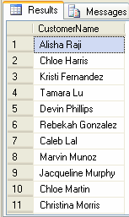
Fig. 8.3. Names of customers who placed orders on the last accounting day
Comment.Such a query can also be designed as a table join. Such queries are processed much faster, so if the query does not need to be executed in several stages, the use of subqueries is not necessary.

Task 3. Determine the list of customers who ordered more than 300 units of goods at one time.
Directions for implementation:
- For each order we need to get the total quantity of the product, for this we will need to create a related subquery.
- In order not to write the full table name before the field names each time, it is convenient to use aliases. In this case, we will define the following aliases: for the SalesOrderHeader table, the alias is oh, and for SalesOrderDetail, the alias is od.
- Resulting the code will look like this: SELECT SalesOrderID, CustomerID
FROM Sales.SalesOrderHeader oh WHERE 300<(SELECT sum(OrderQty)
FROM Sales.SalesOrderDetail od WHERE od.SalesOrderID=oh.SalesOrderID)

Task 4. For each product, display information about its largest order: quantity of ordered product and order number.
Directions for implementation:
- To complete the task, you need to use an inner join between the Product and SalesOrderDetail tables, as well as a related subquery that returns the maximum order for each product.
- In the query, we will need to work with the SalesOrderDetail table both in the outer query and in the inner related subquery. Therefore, for this table, we will create two aliases: od1 and od2.
- Resulting the code will look like this: SELECT Name, OrderQty, SalesOrderID
FROM Production.Product p INNER JOIN Sales.SalesOrderDetail od1 ON od1.ProductID=p.ProductID
WHERE OrderQty = (SELECT Max(OrderQty) FROM Sales.SalesOrderDetail od2
WHERE od1.ProductID=od2.ProductID)

Task 5. Determine the number of different products in each order.
Directions for implementation:
- It is necessary to group records with the same SalesOrderID and count the number of records in each group by the ProductID field. For this, you can use the following query:
SELECT SalesOrderID, count(ProductID) AS [Quantity] FROM Sales.SalesOrderDetail
GROUP BY SalesOrderID
Comment.When using GROUP BY, only one record is returned in the resulting data set for each defined group of values.
- If for each order it is also necessary to calculate the total number of goods in the order, then the request should be supplemented with:

SELECT SalesOrderID, count(ProductID) AS [Quantity], sum(OrderQty) as [Total Quantity] FROM Sales.SalesOrderDetail
GROUP BY SalesOrderID
Comment.When grouping records, the WHERE clause can also be used, in which case records that satisfy this condition are grouped.

Independent work
- Determine the number of employees of a company in the AdventureWorks2008 database.
- Calculate the maximum cost of delivery of orders.
- Display a list of products whose price is higher than the average price.
- Solve this problem using table join.
- For each product, display information about its largest order: name, quantity and order number.
- Note: Use grouping by product name and order number.
- Display a list of products for which more than 50 orders have been received.
Microsoft SQL Server Lab 9: Using Views
Objective: teach how to create and use views when selecting data.
Theoretical material: Before performing the lab, it is recommended that you study Lecture 4, “Data Selection,” which examines one of the main SELECT operators, explains the purpose of each of its sections, and also examines issues of data grouping, and Lecture 5, “Auxiliary Database Objects,” which provides basic information about views.
Reporting requirements: based on the results of the work, present a set of SQL scripts that solve the problems from the “Independent Work” section.

Task 1. Create a view containing only such information about the employees of the AdventureWorks2008 company as: employee ID, his position and login (in one field), date of birth.
Directions for implementation:
- Create a view:
CREATE VIEW InfoEmployees ([Number], [Last Name], [Date of Birth]) AS
SELECT BusinessEntityID, JobTitle + '(' + LoginID + ')', CONVERT (char(10), BirthDate, 104) FROM HumanResources.Employee
- To view the contents of a projection, the following query is executed (the result is shown in Figure 9.1):
SELECT * FROM InfoEmployees
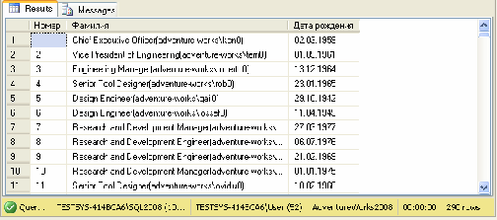
Fig. 9.1. Result of selection from the InfoEmployees view
Comment.This view restricts access to some fields of the original Employee table, in which case the table is said to have a vertical filter, i.e. access to some of the table fields without column-level protection is restricted.

Task 2: Create a view that provides access to information only about manufacturers that have online services for ordering goods.

Directions for implementation:
- By analogy with the previous task, it is necessary to create a vertical filter, i.e. select only one Name field from the Vendor table.
- To cut off "extra" manufacturers, those for which the address of the online order service is unknown, we will use the WHERE section. In this case, we will also create a horizontal filter.
- Code to create a view it would be: CREATE VIEW OnlineVendors AS
SELECT [Name] FROM Purchasing.Vendor WHERE PurchasingWebServiceURL IS NOT NULL

Task 3. Create a view that displays the total cost of each order, indicating the customer and its number.
Directions for implementation:
- To get all the information we need, we need to join the Customer, Person, SalesOrderHeader and SalesOrderDetail tables.
- In order to get the total cost of the order, we need to group the data by the SalesOrderID field. However, we will also need to add the fields that form the customer name to the GROUP BY section, since we will need to specify them in SELECT.
- To determine the cost of one order, we will create the following formula: UnitPrice * OrderQty * (1 – UnitPriceDiscount).
- Resulting The code to create the view will be as follows: CREATE VIEW InfoOrders AS
SELECT FirstName + ' ' + LastName as [Company Name], SalesOrderHeader.SalesOrderID as [Order Number],
Convert (money, SUM(UnitPrice*OrderQty*(1-UnitPriceDiscount)),0) AS [Total] FROM (Person.Person INNER JOIN Sales.Customer
ON Person.BusinessEntityID = Customer.PersonID INNER JOIN Sales.SalesOrderHeader
ON Customer.CustomerID=SalesOrderHeader.CustomerID) INNER JOIN Sales.SalesOrderDetail
ON SalesOrderHeader.SalesOrderID=SalesOrderDetail.SalesOrderID GROUP BY SalesOrderHeader.SalesOrderID, FirstName + ' ' + LastName

Independent work
- Identify 5 customers who are purchasing leaders (format the result as a stored procedure).
Indication: Use the data from the InfoOrders view.
- Display statistics for AdventureWorks2008 showing sales volumes and number of orders by month.
Indication: Create a view that contains the order number, the year and month the order was placed, and the total cost of each order with the discount. To get the year and month the order was placed, use the convert function convert (char(7),OrderDate,102), which converts the date to a string of type yyyy.mm.dd. Since the conversion specifies a string of 7 characters, the result of the function will be a string of type yyyy.mm.
- Create an InfoSalesPerson view that displays salesperson statistics for AdventureWorks2008: the view should include the total amount of orders received and the number of orders received.
- Determine the number of orders placed by season.
Microsoft SQL Server. Lab #10. Database Design
Objective: demonstrate the database design process and teach how to use it
SQL commands for creating tables and managing constraints.
Theoretical material: Before performing the lab work, it is recommended to study Lecture No. 10 “First Normal Forms” and Lecture No. 11 “Fourth and Fifth Normal Forms”, which discuss the need for and the process of normalization itself, which allows maintaining the integrity of the database.

Reporting requirements: based on the results of the work, provide a screenshot with the physical data model, as well as screenshots with SQL commands and the results of their execution for tasks No. 2 and
No. 3 from the section "Independent work".

Database Design Stages
From the Microsoft perspective, database design consists of two phases: logical and physical modeling. During logical design, a database model is developed that is independent of a specific DBMS. During physical design, a database model is created that is optimized for a real DBMS.
The database design process consists of the following steps:
- Collection of information.
- Identification of objects and their modeling.
- Defining the types of information for each object.
- Relationship identification.
- Normalization.
- Creating a database.
The first five stages belong to the logical modeling phase, and the sixth stage belongs to the physical modeling phase.

Logical model
We will develop a logical structure for a database that stores information about teachers and the courses they teach, information about students and the classes they attend.
It has been established that:
- a student can attend any number of courses;
- teachers can teach several subjects;
- the course is taught to a certain audience;
- Only one subject is taught in one classroom.
Thus, the following objects are distinguished: Teachers, Students, Disciplines and Classrooms. The following relationships exist between the objects: Students–Disciplines (many-to-many, implemented through the additional object Registration), Teachers–Disciplines (one-to-many), Classrooms–Disciplines (one-to-one).
Each object must contain the following information.

Teachers:
- surname, first name, patronymic – mandatory attribute;
- date of birth is a mandatory attribute, it cannot be greater than today's date and less than 1900;
- home address is a required attribute; if not specified, the default value is 'unknown';
- phone – a mandatory attribute, either specified in the format 00-00-00, or if it is absent, 'no' is specified by default.
- hire date is a mandatory attribute, cannot be greater than today's date and less than the date of birth, today's date is set by default;
- Experience is a calculated field, determined by the difference between today's date and the hire date.

Students:
- surname, first name, patronymic – mandatory attribute;
- date of birth is a mandatory attribute, it cannot be greater than today's date and less than 1900;

Disciplines:
- the name of the discipline is a mandatory attribute;
- the name of the teacher teaching the course, the list of students attending the course, the audience – foreign key.

Audiences:
- number is a mandatory attribute;
- audience type is a required attribute.

Physical model
When moving from a logical model to a physical one, it is necessary to ensure data integrity, which is understood as the consistency and correctness of the information in the database.
There are 4 groups of integrity rules:
- Value domain (or field) integrity: defines the set of valid values ​​for a field, including whether NULL values ​​are allowed.
- Entity integrity: requires that each table record have a unique identifier – the primary key value.
- Referential integrity: ensures that the relationship between the primary key and the foreign key is maintained at all times, i.e. it prohibits deleting a record or changing its primary key value if it is referenced by a foreign key, and it prohibits adding a record with a foreign key value that does not correspond to any primary key value.
- User-defined integrity specifies user-specific rules that cannot be assigned to any group.
Data integrity can be ensured in two ways.
- Declarative method.The criteria that the data must satisfy are specified when the object is defined and are part of the database definition.
Advantages:Integrity control is performed automatically by MS SQL Server, this method is fully compatible with the ISO SQL:2008 standard.
- Procedural method.The criteria are described in operator packages, the execution of which determines the integrity of the data.
Advantages: implemented both on the client and on the server using various software tools.

Declarative integrity
It is implemented using constraints that are the most recommended for ensuring data integrity. Each type of integrity is ensured by a corresponding constraint:
- PRIMARY KEY. Defining a field or group of fields as a primary key allows you to uniquely identify each record in the table, since duplicate and NULL values ​​are not allowed.
- FOREIGN KEY. Allows you to establish a relationship between fields containing identical data. The data in this field can take the values ​​defined in the corresponding primary key or NULL values.
- UNIQUE. Defines the uniqueness of data in a certain field of a table, and this constraint allows NULL values. In one table, the use of several such constraints, fields with such a constraint can be used as foreign keys.
- DEFAULT. Specifies the default value for the field if a value is not explicitly specified when inserting data. Only one such constraint can be applied to a field.
- CHECK. Imposes a constraint on the field value in the form of a logical expression, which allows you to determine the range of acceptable field values. Moreover, this constraint allows you to refer to the values ​​of other fields.
To obtain information about the restrictions used by the specified table, a special stored procedure is used:
sp_helpconstraintTableName

Creating a table
For example, to create a table storing information about students, you need to run the command:
CREATE TABLE Students (StudentID int IDENTITY(1,1)
CONSTRAINT prkStudentID PRIMARY KEY,
LastName char(20) NULL, FirstName char(20) NULL, BirthDate datetime NULL
CONSTRAINT bdChek CHECK (BirthDate < GetDate()) )

To obtain information about the properties of a table, you need to execute a special stored procedure: sp_help TableName.

Projections of the information scheme
System information about the database and all its objects is called metadata, for obtaining which MS SQL Server provides many different ways: calling system stored procedures and information schema views, as well as using the SQL Management Studio administration utility.
Information schema views provide an external view of metadata independent of the system tables. These views are owned by a predefined user, information_schema. Each view contains metadata for objects in a database.
For example, the following views return metadata about the current database constraints:
- table_constraints – list of all database constraints.
- check_constraints – list of CHECK type constraints.
- referential_constraints – list of referential integrity constraints.

Independent work
- Based on the described logical model of the database, create its physical model.
- Define metadata of the PRIMARY KEY constraints in the created database, specifying the names of the constraints and the tables to which they apply.
- Output logical expressions of CHECK constraints.

Microsoft SQL Server. Lab #11. Data Management
Target:teach how to use SQL statements to insert, modify, and delete data from tables.
Theoretical material: Before performing the lab, it is recommended to study Lecture #4 “Data Selection”, which requires knowledge of the SELECT operator, which is necessary for inserting data into one table from another, as well as Lecture #9 “Relational Algebra Operators”, which covers the theoretical aspects of the basic data management commands.
Reporting requirements: based on the results of the work, submit a set of SQL scripts that solve the problems from the "Independent Work" section, as well as a text file required for the task
No. 2 from the same section.

Task 1. Add a record to the Lect table with the specified field values ​​and default values.
Instructions for implementation:
- Let's set values ​​for three fields: Brdate, FirstName, LastName.
- We will not specify the counter field, since it will be generated automatically.
- Use the following code to insert a new record: INSERT INTO Lect (Brdate, FirstName, LastName) VALUES (Convert(datetime,'01.01.1970',104), '...', '...')
Comment.Running the INSERT INTO Lect DEFAULT VALUES command will result in an error because not all fields have default values ​​specified.

Task 2. Add data from the Employee table of the database to the Lect table

AdventureWorks2008:
Directions for implementation:
- We will fill in 4 fields in the Lect table: FirstName, LastName, Brdate, HireDate.
- For To insert several records at once, use the SELECT operator: INSERT INTO Lect (FirstName, LastName, Brdate, HireDate)
SELECT FirstName, LastName, BirthDate, HireDate FROM AdventureWorks2008.HumanResources.Employee INNER JOIN AdventureWorks2008.Person.Contact
ON Contact.ContactID = Employee.ContactID
Comment.When using the SELECT command, multiple records are inserted into a table,

that are the result of selecting data from other tables. However, if even one of the inserted records violates the integrity constraints of the table, the entire INSERT command is canceled.

Task 3. Add data from the file to the Students table.
Directions for implementation:
- Create a text file students.txt in the root of drive C: with the following contents:
  - Ivan Petrov1.1.1990
  - Petr Ivanov12.10.1992
  - Sergey Kazakov5.3.1991

Comment.TAB is used as a line separator instead of spaces.
- Run the following code:
BULK INSERT Students FROM 'c:\students.txt'
Comment.Note that although we specified the StudentID fields in the students.txt file, they were ignored during the insert. This is because we did not use the KEEPIDENTITY option.

Task 4. Change the phone number of a teacher named King.
Directions for implementation:
- To find the desired name, we will use the LIKE operator.
- Let's install it for all teachers 'King' phone equal 35-35-35: UPDATE Lect
SET Phone = '35-35-35'
WHERE FirstName like 'King'

Task 5. Specify that computer science courses should be taught by a teacher named

King.
Instructions for implementation:
- To update records in the Course table, we need to use a subquery that returns the desired teacher: SELECT LectID From Lect Where (FirstName like 'King').
- It is important to remember that the subquery must return a single value for each record.
- Code to update the computer science teacher it will look like this: UPDATE Course SET LectID =
(SELECT LectID From Lect Where (FirstName like 'King')) WHERE CourseName like '%[Ii]nform%'

Task 6. Remove all students with the last name Ivanov.
Directions for implementation:
- To delete records based on a given condition, you must use the WHERE clause in the DELETE statement.
- Do it the following code to delete students: DELETE Students
WHERE LastName = 'Ivanov'
Comment.Removing data from a table is performed row by row, and it is possible to delete either one record or several records that satisfy a certain condition. However, to delete all records of a certain table, the following command is recommended: TRUNCATE TABLE TableName. In this case, all records are deleted, but the table structure is preserved, as are the objects associated with it. This command is executed faster than the DELETE command, since the server only registers the release of memory pages, and not the deletion of each record from the page.

Independent work
- Fill in the Lect and Class tables of the created database.
- Fill in the Students table of the created database from the text file.
- Fill in the remaining tables of the created database.
Remove all students born before 1990.

